**Sorting of numbers in a sequence**

**Exp 3 (a) : Ascending Order Aim Aim:**

To write and execute an 8085 program to sort a set of numbers in ascending order.

**Apparatus Required:**

* 8085 Online Simulator (8085simulator.github.io or similar)
* Test input data
* Instruction set reference

**Algorithm (Ascending Order):**

* 1. Load count from memory into register C.
  2. Subtract 1 from count and store in B (outer loop counter).
  3. Outer loop (B times):

Point HL to the first data.

Copy C to D (inner loop counter).

Inner loop (D times):

Compare adjacent elements.

If current > next, swap them. Decrement B and repeat.

* 1. End.

**Program:**

; --- Read 5 inputs from ports 01H–05H ---

IN 01H

STA 0000H IN 02H

STA 0001H IN 03H

STA 0002H IN 04H

STA 0003H

IN 05H

STA 0004H

; --- Bubble Sort (on memory 0000H–0004H) ---

MVI C, 04H ; outer loop count = 4 passes

OUTER: LXI H, 0000H ; HL -> first element

MOV B, C ; inner loop counter

INNER: MOV A, M ; A = [HL]

INX H ; next element

CMP M ; compare A with [HL]

JC NOSWAP

JZ NOSWAP

## ; Swap

MOV D, M ; D = [HL]

## MOV M, A ; [HL] = A

DCX H

MOV M, D ; [HL] = D

INX H ; back forward

# NOSWAP: DCR B

## JNZ INNER

DCR C

JNZ OUTER

; --- Output sorted numbers to ports 06H–0AH ---

LDA 0000H OUT 06H

LDA 0001H OUT 07H

LDA 0002H OUT 08H

LDA 0003H OUT 09H

LDA 0004H

OUT 0AH

HLT

**Output:**

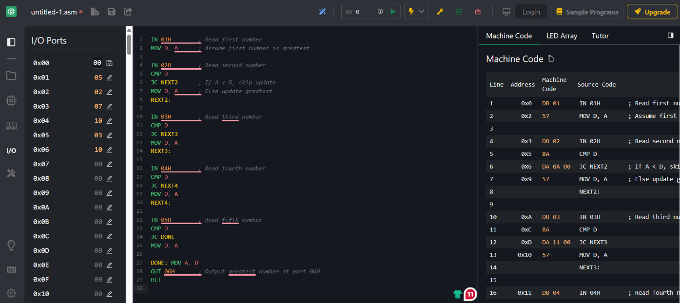

**Input Ports**:

* 01H → First number

* 02H → Second number

* 03H → Third number

* 04H → Fourth number

* 05H → Fifth number

**Output Ports (Sorted Result)**:

* 06H → Smallest number

* 07H → 2nd number

* 08H → 3rd number

* 09H → 4th number

* 0AH → Largest number

**Result:**

The 8085 assembly language program was successfully executed to sort a set of numbers in ascending order.

**Exp 3 (b) : Descending Order Aim:**

To write and execute an 8085 program to sort a set of numbers in descending order.

**Apparatus Required:**

• 8085 Online Simulator • Hex input data • Instruction set reference

**Algorithm (Descending Order):**

1. Load the count of numbers from memory into register C.
2. Subtract 1 from count and store in B.
3. Outer loop (B times):

Point HL to first number.

Copy count to D.

Inner loop (D times):

Compare adjacent numbers. If current < next, swap them.

1. Repeat until sorted.

**Program:**

; --- Read 5 inputs from ports 01H–05H ---

IN 01H

STA 0000H IN 02H

STA 0001H IN 03H

STA 0002H IN 04H

STA 0003H

IN 05H

STA 0004H

; --- Bubble Sort (Descending) --- MVI C, 04H ; outer loop count = 4 passes

OUTER: LXI H, 0000H ; HL -> first element

MOV B, C ; inner loop counter

INNER: MOV A, M ; A = [HL]

INX H ; next element

CMP M ; compare A with [HL]

JNC NOSWAP ; if A >= [HL], no swap

JZ NOSWAP

; --- Swap ---

MOV D, M ; D = [HL]

MOV M, A ; [HL] = A

DCX H

MOV M, D ; previous = D

INX H ; forward again

NOSWAP: DCR B

JNZ INNER

DCR C

JNZ OUTER

; --- Output sorted numbers to ports 06H–0AH ---

LDA 0000H

OUT 06H ; Largest

LDA 0001H OUT 07H

LDA 0002H OUT 08H

LDA 0003H OUT 09H

LDA 0004H

OUT 0AH ; Smallest

HLT

**Output:**



**Port Mapping**

* **Input Ports**:

* 1. 01H → First number

○ 02H → Second number

○ 03H → Third number

○ 04H → Fourth number

○ 05H → Fifth number

* **Output Ports (Descending Order)**:

* 1. 06H → Largest number

○ 07H → 2nd largest

○ 08H → Middle value

○ 09H → 2nd smallest

○ 0AH → Smallest number

**Result:**

The 8085 assembly language program was successfully executed to sort a set of numbers in descending order.